Student Payment Form:

First Name: Last Name:
Country: Passport Number: Date:
Amount: Name of Program:

Please choose a method of payment and check the appropriate box.
After completion, please send this form to:ortala@int.technion.ac.il

USD by Bank transfer:
Beneficiary: Technion Israel Institute of Technology-International School
Account number: 7002/44
Bank: Bank Leumi Le Israel B,M ,Bank no. 10
Account (IBAN): IL930108780000000700244
Branch: Hadar – Haifa , Branch number: 878
Address: 33 Herzel St., Haifa 33504 Tel: +972-4-8612888
Bank Swift Code: LUMIILITTLV

NIS by Bank transfer:
Beneficiary: Technion Israel Institute of Technology-International School
Account number: 15300031
Bank: Bank Leumi Le Israel B,M ,Bank no. 10
Branch: Hadar – Haifa , Branch number: 878
Address: 33 Herzel St., Haifa 33504 Tel: +972-4-8612888

Please scan and email a copy of your transfer certification to:ortala@int.technion.ac.il or Fax to +972-77-887-1852

Personal check
Made out to the Technion Israel Institute of Technology
Please send to:
Mauerberger Building, 2nd floor
Technion International
Technion City, Haifa
32000, Israel
ATTN: Ms. Liubov Baladzhaeva
Credit Card:

Type of Card:

Card number:

Card holder:

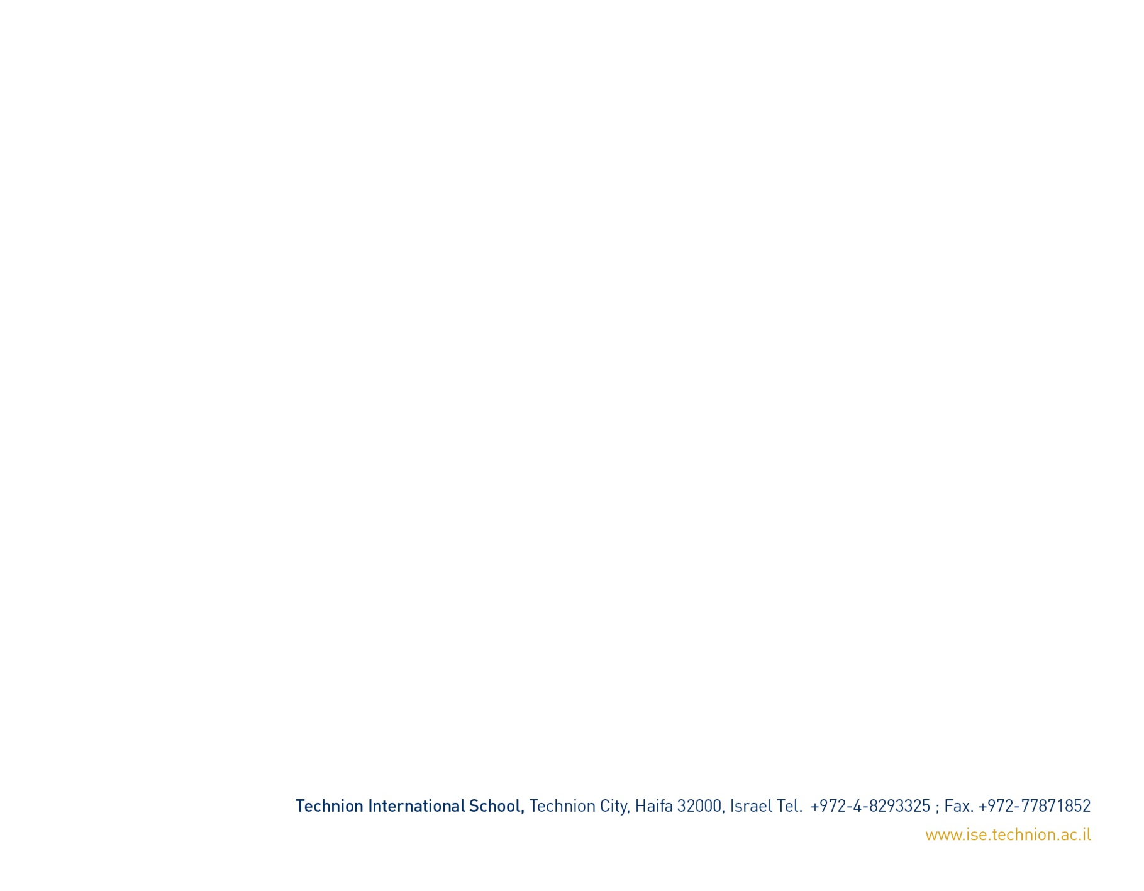
Expiry date:

